
Savitribai Phule Pune University
INTERDISCIPLINARY SCHOOL OF SCIENTIFIC COMPUTING
Mid Sem Exam - III
Course No. : SC 104
Title : Mathematics for Scientific Computing

Date : 07 / 11 / 2015 Marks : 40
Time : 11:00 am to 01:00pm

Q.1 Attempt any five. ( 2 marks each).
(i) Find the limit of the sequence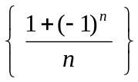
∞
∑
n = 1
(ii) Examine convergence of the series 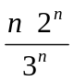
∞
∑
n = 1
(iii) Find the radius of convergence of the power series 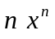

(iv) Show that the line 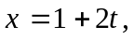 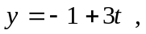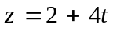
is parallel to the plane 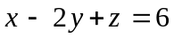

(v) Find the angle between the vectors 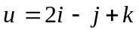 and 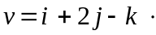

(vi) Find the angle between the planes 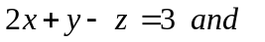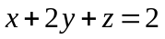

(vii) Find solution of the differential equation 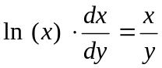
(viii) Write down the general solution of the 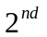order differential equation
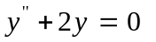
Q.2 (a) Examine the convergence of the following alternating series. ( Any one, 3 marks)
∞
∑
n = 0
∞
∑
n = 1
- 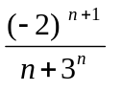 (ii) 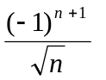

(b) Obtain the following expression using term by term integration of power (3)
series.
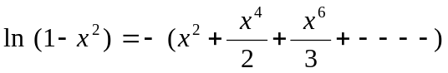

Q.3 Find the Fourier Series for the function (6)
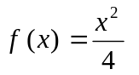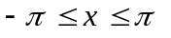
Using the above series show that
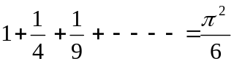

Q.4 Solve any two ( 3 marks each).

(i) Find the equation of the plane passing through the points

(ii) Find the equation of the line of intersection of the planes 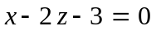and
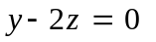

(iii) Find the equation of the plane through point 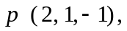perpendicular to the line
of intersection of the planes 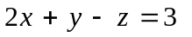and 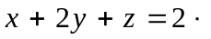

Q.5 (a) Solve any one. ( 3 marks)
(i) 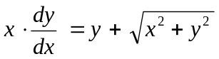
(ii)

(b) Solve any one. ( 3 marks)
(i) 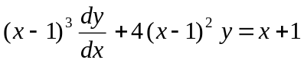
(ii) 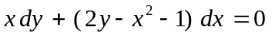

Q.6 (a) Are the vectors 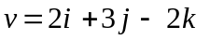and 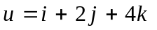perpendicular to each (1)
other?

(b) Obtain the general sol^{n} of the following differential equation. ( Any one.) (5)
(i) 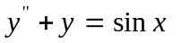
(ii)



